<Prize Bond Checking App>
Software Requirements Specification

Version 1.0



Group Id: <F25PROJECT4872C (BC220408046)>
Supervisor Name :<Saeed Nasir>

Revision History
Date (dd/mm/yyyy) | Version | Description | Author
05/11/2025 | 1.0 | This project is a mobile application built to streamline prize bond management for Pakistani users. It offers secure authentication, automated prize checking, OCR-based scanning, and access to official draw results both online and offline. Users can save bond numbers, receive instant win notifications, and trade bonds through an integrated marketplace. Backed by a robust backend for data handling and verification, the app delivers fast performance, accurate results, and a user-friendly experience across Android devices. | BC220408046

Table of Contents

- Scope (of the project)
- Functional Requirements Non Functional requirements
- Use Case Diagram
- Usage Scenarios
- Adopted Methodology
- Work Plan (Use MS Project to create Schedule/Work Plan)

- Scope:

The Prize Bond Checking Mobile Application is designed to simplify, automate, and enhance the process of managing Pakistani prize bonds. The system provides users with a mobile-based platform to scan, check, save, and manage their prize bond numbers efficiently. The backend handles authentication, database operations, prize draw data management, and result verification.

This application targets convenience, accuracy, and usability, aiming to eliminate the inefficiencies of manual prize bond checking and provide real-time access to official draw results.

The application allows users to:
- Access official prize bond draw results both online and offline.
- Automatically check saved bond numbers against new draw results.
- Receive alerts and notifications when bonds win.
- Buy and sell bonds through a built-in marketplace.
- Maintain high performance, security, and usability standards across Android devices.

The system will consist of three major modules: User Module, Admin Module, and System Module, supported by a central database.

Definitions, Acronyms, and Abbreviations
- OCR: Optical Character Recognition
- SRS: Software Requirements Specification
- API: Application Programming Interface

Assumptions and Dependencies
- Users possess Android devices (Android 8.0+).
- Internet connection is required for full functionality (except offline checking).

- Functional & Non-Functional Requirements:

2.1 User Module

2.1.1 User Account / Authentication
- Create account via email/password.
- Secure login and logout.
- Passwords stored using hashed and salted encryption.
- Edit profile information.

2.1.2 Bond Management (My Bonds)
- Add, view, edit, or delete saved prize bonds.
- Automatic checking of saved bonds against latest draw results.
- Display winning bonds with visual indicators.
- Maintain bond history and detailed information.

2.1.3 Prize Bond Checking
- Manual entry or file upload of bond numbers.
- Validate input and check against latest draw data.
- Display results with draw date, denomination, and prize amount.

2.1.4 Prize Bond Scanner
- Use mobile camera for scanning printed bonds.
- OCR automatically extracts bond numbers, reducing manual errors.

2.1.5 Offline Checking
- Download draw results for offline use.
- Perform checks without internet connectivity.
- Automatic synchronization once reconnected.

2.1.6 Marketplace (Buy & Sell Bonds)
- Add new sale listings.
- Browse, search, and filter available bonds for sale.
- Secure transaction support.

2.1.7 Alerts & Notifications
- Notify users of winning bonds.
- Alerts for new draw updates.
- Marketplace notifications (new listings, messages).

2.1.8 Search & Filter
- Search bonds by number, denomination, draw date, and draw number.
- Apply filters for precise retrieval of results.

2.2 Admin Module

2.2.1 Admin Account Management
- Secure login to admin dashboard.
- Add, view, edit, or delete admin accounts.

2.2.2 User Management
- View registered users and edit details.
- Remove users violating policies.

2.2.3 Prize Draw Data Management
- Upload new draw results manually via a file or re-fetch results from National Listings.
- Maintain an archive of previous draws.

2.2.4 Marketplace Moderation
- Monitor buy/sell listings.
- Remove suspicious or fraudulent posts.

2.2.5 Review & Actions on Reports
- Handle complaints or flagged content.
- Approve or delete listings, accounts, or messages violating rules.

2.3 System Module

2.3.1 Draw Result Database
- Detect and verify newly uploaded results.

2.3.2 Data Storage
- User accounts, bond numbers, prize draw results, marketplace listings, notifications, and logs.
- Fast retrieval and scheduled backups.

2.3.3 Multi-Denomination Support
- Support official denominations: 100, 200, 750, 1500, 25000, 40000 PKR.

2.4 Non-Functional Requirements

2.4.1 Performance
- Support at least 10,000 concurrent users.
- Bond check operations complete within 3 seconds.

2.4.2 Scalability
- Backend scalable using Docker containers.
- Database optimized for large datasets.

2.4.3 Security
- Encrypted communications (HTTPS).
- No plain-text storage of sensitive information.
- Protection against SQL injection, unauthorized access, and spam.

2.4.4 Usability
- Mobile UI built using Material Design principles.
- Intuitive navigation, accessibility compliant.

2.4.5 Maintainability
- Layered architecture: UI, business logic, and data layers.
- Well-documented APIs.

2.4.6 Availability & Reliability
- 99.5% uptime with cloud hosting.
- Daily backups and failover systems.

2.4.7 Compatibility
- Android devices running Android 8.0 and above.

- Use Case Diagram(s):

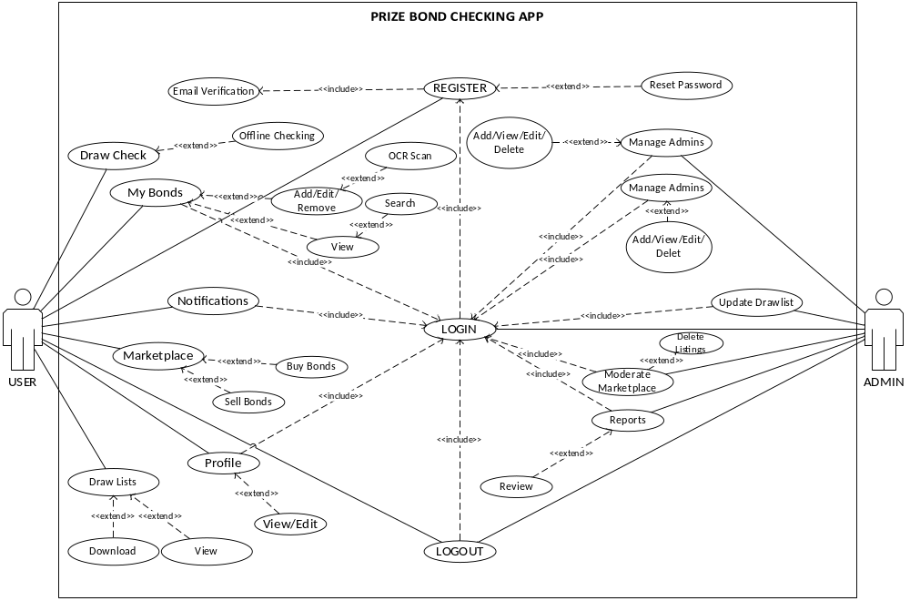

- Usage Scenarios:

User module

Use case title | User Registration
Use case ID | UM-1.1
Actors | User
Description | Allows a new user to create an account.
Pre-conditions | Internet connection should be available.  User does not already have an account.
Task sequence |  |  | Exceptions
- Open the app.  - Click “Login”.  - Click “Sign Up”.  - Enter email, password, and other required details.  - Click “Submit”. |  |  | - Email already exists.  - Password does not meet security requirements.  - Something went wrong.
Post  condition |  | Account created successfully; user is logged in automatically.
Author |  | BC220408046

Use case title | User Login
Use case ID | UM-1.2
Actors | User
Description | Allows a registered user to login.
Pre-conditions | Internet connection should be available.  The user has a valid account.
Task sequence |  |  | Exceptions
- Open the app.  - Click “Login”.  - Enter email and password.  - Click “Submit”. |  |  | - Incorrect email or password.  - Account temporarily blocked.
Post  condition |  | User successfully logged in; dashboard displayed.
Author |  | BC220408046

Use case title | Add Prize Bond
Use case ID | UM-2.1
Actors | User
Description | Allows user to add a new bond to his saved list.
Pre-conditions | Must be logged in.
Task sequence |  |  | Exceptions
- Navigate to “My Bonds.”  - Click “Add Bond.”  - Enter bond number and select denomination, and details.  - Click “Add”. |  |  | - Bond number already exists.  - Invalid bond number format
Post  condition |  | Bond is saved successfully and visible in the list.
Author |  | BC220408046

Use case title | Edit Prize Bond
Use case ID | UM-2.2
Actors | User
Description | Allows user to edit saved bond details.
Pre-conditions | User logged in.  Bond exists in account.
Task sequence |  |  | Exceptions
- Navigate to “My Bonds.”  - Click on the bond to edit.  - Click on “Edit”.  - Update details as needed.  - Click “Save Changes.” |  |  | - All fields are required.  - 6. Invalid input format.
Post  condition |  | Changes saved successfully.
Author |  | BC220408046

Use case title | Delete Prize Bond
Use case ID | UM-2.3
Actors | User
Description | Allows user to delete a saved bond.
Pre-conditions | Must be logged in.  Bond exists in account
Task sequence |  |  | Exceptions
- Navigate to “My Bonds.”  - Click on “Delete” icon.  - Select bond to delete.  - Click “Delete.”  - Confirm deletion. |  |  | - Deletion canceled by user.  - Something went wrong.
Post  condition |  | Bond removed successfully from user account.
Author |  | BC220408046
Use case title | Check Prize Bond
Use case ID | UM-3.1
Actors | User
Description | Allows user to check if a bond has won.
Pre-conditions | Internet connection should be available.
Task sequence |  |  | Exceptions
- Navigate to “Check Bond.”  - Enter bond number manually or scan using camera.  - Click “Check.” |  |  | - Draw data unavailable.  - Something went wrong.
Post  condition |  | Bond result displayed (winner/non-winner).
Author |  | BC220408046

Use case title | Scan Prize Bond (OCR)
Use case ID | UM-3.2
Actors | User
Description | Allows the user to scan printed bonds using mobile camera
Pre-conditions | User logged in.  Camera permission granted.
Task sequence |  |  | Exceptions
- Navigate to “My Bonds”.  - Click on “Add Bond”.  - Click on the “Scan” icon.  - Scan the Bond.  - Verify the scanned info.  - Click “Add”. |  |  | - Camera not available.  - OCR fails to recognize number.  - Something went wrong.
Post  condition |  | Bond number captured and saved or checked.
Author |  | BC220408046

Use case title | Offline Prize Bond Checking
Use case ID | UM-3.3
Actors | User
Description | Allows user to check bonds without internet.
Pre-conditions | Draw data downloaded for offline use.
Task sequence |  |  | Exceptions
- Navigate to “Offline Check.”  - Select or enter bond number.  - Click “Check.” |  |  | - Offline data not downloaded.  - Something went wrong.
Post  Condition |  | Result displayed from offline data.
Author |  | BC220408046

Use case title | Receive Notifications
Use case ID | UM-4.1
Actors | User
Description | Alerts users about winning bonds or draw updates.
Pre-conditions | User logged in.  Notifications are enabled  Internet connection is available
Task sequence |  |  | Exceptions
- Enable notifications in app settings.  - System monitors saved bonds.  - Notify user for winning bonds or new draw results. |  |  | - Notifications disabled,  - Internet connection unavailable.  - Something went wrong.
Post  condition |  | User receives alerts successfully.
Author |  | BC220408046

Use case title | Browse Marketplace
Use case ID | UM-5.1
Actors | User
Description | Allows user to view bonds available for sale.
Pre-conditions | Internet connection should be available.
Task sequence |  |  | Exceptions
- Navigate to “Marketplace.”  - Browse available bonds.  - Apply filters/search if needed. |  |  | - No internet connection.  - No matching results.  - Marketplace data unavailable.  - Something went wrong.
Post  condition |  | User views listings successfully.
Author |  | BC220408046

Use case title | Add Marketplace Listing
Use case ID | UM-5.2
Actors | User
Description | Enables user to list bonds for sale.
Pre-conditions | Internet connection should be available.  Must be logged in.
Task sequence |  |  | Exceptions
- Navigate to “Marketplace.”  - Click “Add Listing.”  - Enter bond details and price.  - Click “Submit.” |  |  | - Invalid price or bond details.  - Something went wrong.
Post  condition |  | Listing added successfully and visible to other users.
Author |  | BC220408046

Use case title | Profile(edit):
Use case ID | UM-6.1
Actors | User
Description | This use case enables the user to edit their profile.
Pre-conditions | Internet connection should be available.  Must be logged in.
Task sequence |  |  | Exceptions
- Go to “My Profile”.  - Click edit button.  - Re-enter data and click save changes button. |  |  | - Something went wrong.
Post  condition |  | Changes saved successfully.
Author |  | BC220408046

Use case title | Logout:
Use case ID | UM-6.2
Actors | User
Description | This use case enables the user to logout
Pre-conditions | Internet connection should be available.  Must be logged in.
Task sequence |  |  | Exceptions
- Go to “My Profile”  - Click logout button. |  |  | - Something went wrong.
Post  condition |  | Success.
Author |  | BC220408046

Admin Module

Use case title | Admin Login:
Use case ID | AM-1.1
Actors | Admin.
Description | This use case enables the admin to login.
Pre-conditions | Internet connection should be available.  Valid admin credentials.
Task sequence |  |  | Exceptions
- Open the app.  - Click “Login” button.  - Press “Admin Login”.  - Enter login credentials.  - Click “Submit”. |  |  | - All fields are required.  - Email or password is incorrect.  - Something went wrong.
Post  condition |  | Admin successfully logged in.  Dashboard displayed
Author |  | BC220408046

Use case title | Manage admins (add):
Use case ID | AM-2.1
Actors | Admin
Description | This use case enables the admin to add new admins.
Pre-conditions | Internet connection should be available.  Must be logged in.
Task sequence |  |  | Exceptions
- Login to admin panel.  - Click admins button.  - Click add new button.  - Enter details and click add button. |  |  | - All fields are required.  - Email already registered.  - Something went wrong.
Post  condition |  | Admin added successfully.
Author |  | BC220408046

Use case title | Manage admins (delete):
Use case ID | AM-2.2
Actors | Admin
Description | This use case enables the admin to delete existing admins.
Pre-conditions | Internet connection should be available.  Must be logged in.
Task sequence |  |  | Exceptions
- Login to admin panel.  - Click admins button.  - Click delete button. |  |  | - Something went wrong.
Post  Condition |  | Admin deleted successfully.
Author |  | BC220408046

Use case title | Manage Users
Use case ID | AM-3.1
Actors | Admin
Description | Enables admin to view, edit, or remove registered users.
Pre-conditions | Internet connection should be available.  Must be logged in.
Task sequence |  |  | Exceptions
- Navigate to “User Management”.  - Select a user.  - Edit details or click “Remove User”.  - Confirm action. |  |  | - Something went wrong.
Post  condition |  | User details updated or user removed successfully.
Author |  | BC220408046

Use case title | Moderate Marketplace
Use case ID | AM-4.1
Actors | Admin
Description | Allows admin to monitor and remove suspicious listings
Pre-conditions | Internet connection should be available.  Must be logged in.
Task sequence |  |  | Exceptions
- Navigate to “Marketplace Moderation.”  - Review listings.  - Remove any suspicious listing.  - Select or Enter reason for removal.  - Confirm action. |  |  | - All fields are required.  - Something went wrong.
Post  condition |  | Suspicious listings removed.  Marketplace remains clean and secure.
Author |  | BC220408046

Use case title | Upload Prize Draw Results
Use case ID | AM-5.1
Actors | Admin
Description | Enables admin to upload new prize draw results.
Pre-conditions | Internet connection should be available.  Must be logged in.
Task sequence |  |  | Exceptions
- Login to account.  - Go to “Draw Lists”.  - Select denomination.  - Select if automatically fetch data or upload a file. |  |  | - National Listing Website is down.  - Incorrect File Format.  - Backend server is down.  - Something went wrong.
Post  condition |  | Draw results are uploaded & visible to users.
Author |  | BC220408046

Use case title | Handle Reports & Complaints
Use case ID | AM-6.1
Actors | Admin
Description | Enables admin to handle user complaints and reports.
Pre-conditions | Internet connection should be available.  Must be logged in.  Reports/Complaints exists in the system.
Task sequence |  |  | Exceptions
- Login to admin panel.  - Navigate to “Reports/Complaints.”  - Select a report.  - Take appropriate action (approve, remove, or warn).  - Record action taken. |  |  | - Report already solved by another admin.  - Something went wrong.
Post  condition |  | Reports handled.  Actions logged successfully.
Author |  | BC220408046

- Adopted Methodology

5.1 Spiral Model:

The spiral model is a risk-driven software development process model. Based on the unique risk patterns of a given project, the spiral model guides a team to adopt elements of one or more process models, such as incremental, waterfall, or evolutionary prototyping.

The spiral model is a cyclical process that consists of four main phases:

- Planning: In this phase, the team defines the scope of the project, identifies the risks, and develops a plan to mitigate those risks.
- Design: In this phase, the team designs the system architecture and the individual components of the system.
- Construction: In this phase, the team constructs the system components and integrates them into a working system.
- Testing: In this phase, the team tests the system to ensure that it meets the requirements.

The spiral model is a more iterative and risk-driven approach to software development than the waterfall model. It is often used for large and complex projects where there is a high degree of uncertainty.

Here are some of the advantages of the spiral model:

- It is a risk-driven approach, which means that the team can focus on mitigating the risks that are most likely to impact the project.
- It is an iterative approach, which means that the team can learn from each iteration and improve the system as it is developed.
- It is a flexible approach, which means that the team can adapt the plan as needed to accommodate changes in the project.

Here are some of the disadvantages of the spiral model:

- It can be more time-consuming and expensive than other approaches.
- It can be more complex to manage than other approaches.
- It can be difficult to get everyone on the team to agree on the risks and how to mitigate them.

Overall, the spiral model is a good choice for large and complex projects where there is a high degree of uncertainty. It is a risk-driven and iterative approach that can help the team to develop a high-quality system.

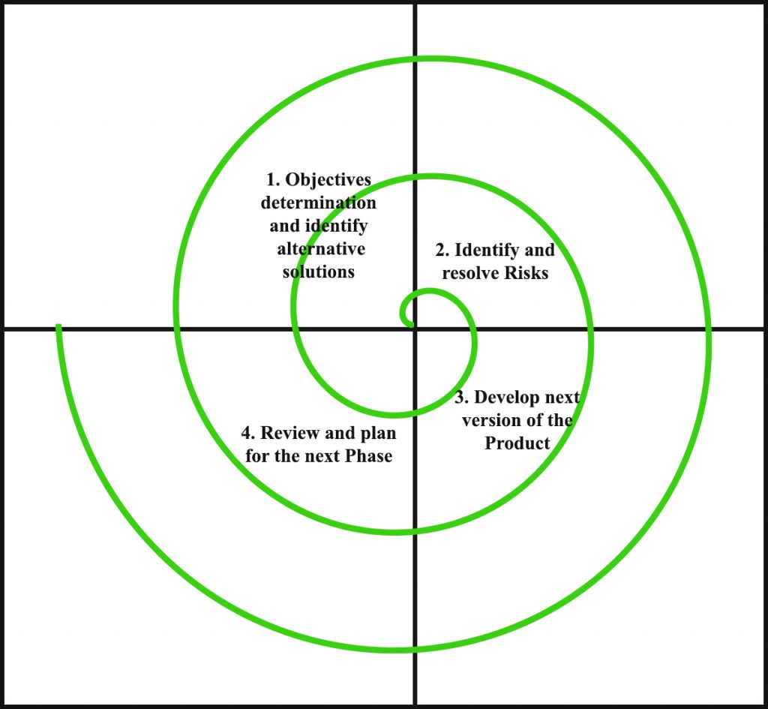

  - Waterfall Model:

The waterfall model is a software development process model that follows a linear sequential approach. This means that each phase of the development process must be completed before the next phase can begin. The waterfall model is divided into the following phases:

- Requirements gathering: In this phase, the project team gathers the requirements from the customer or user.
- System design: In this phase, the project team designs the system architecture and the individual components of the system.
- Implementation: In this phase, the project team constructs the system components and integrates them into a working system.
- Testing: In this phase, the project team tests the system to ensure that it meets the requirements.
- Deployment: In this phase, the system is deployed to the users.
- Maintenance: In this phase, the system is maintained and updated to address any issues or changes in requirements.

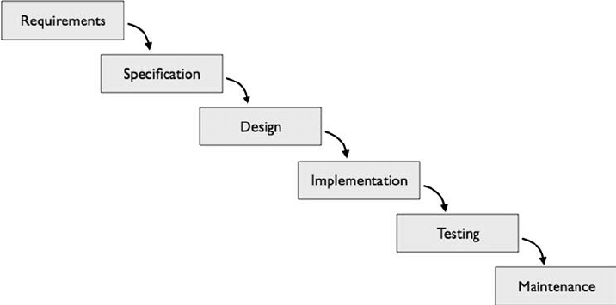

- Work Plan

